PRIORITIZING TASKS

PRIORITIZING TASKS
- The goal is to allow the user to be able to drag tasks up and down within the listbox to prioritize and deprioritize tasks

GLOBAL drag_start_index
- We'll use a global variable to remember which task the user first clicked
- NONE means that no task is currently being dragged
- We're using a global variable because the mouse-drag will happen across multiple separate functions

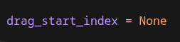

STARTING THE MOUSE-DRAG EVENT
- We'll define a function start_drag(event)
  - NOTE that functions being called with an event need an event parameter
- We'll call the global drag_start_index
- We'll grab the task row closes to the beginning the mouse-drag with .nearest(event.y) and save this to our global variable

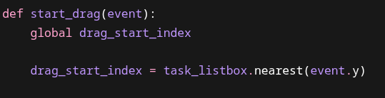

DRAGGING THE TASK
- This function runs while the user holds the mouse button and moves the mouse button
- We'll call the global variable drag_start_index
- We'll create a new variable new_index to get the task row closest to the drag event with .nearest(event.y)
- We'll cover edge cases in case no drag has started or if the drag is equal to the same task row from the beginning of the drag event
- If the drag event is successful, we'll pop the task from it's original position from our global variable tasks
- We'll then insert the task to its new index in our global variable tasks
- We'll call the refresh_listbox( ) function to update our listbox widget (we haven't yet created this function)
- We'll use .selection_set(new_index) to highlight the tasks new position
- We'll update the global variable drag_start_index with new_index in case the user keeps dragging the task

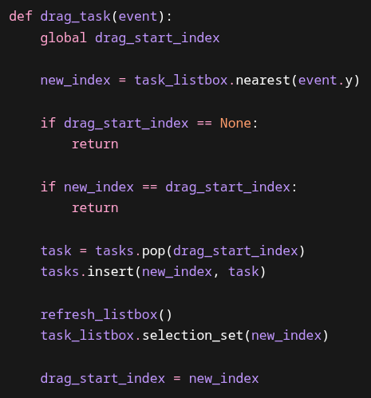

END OF THE MOUSE-DRAG
- We'll define a function stop_drag(event) to handle when the user releases the mouse button and ends the mouse-drag
- We'll save the new order of our tasks

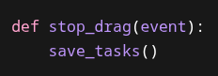

REFRESHING THE LISTBOX
- We'll use this function in conjunction with drag_task(event) to constantly update the task list order while the user is dragging tasks
- In order to refresh the listbox widget, we'll first have to delete every entry
- Then we'll use a for-loop to iterate over our global tasks and insert each task

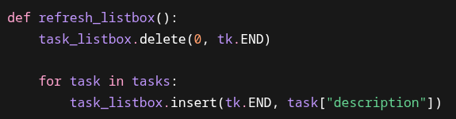

BINDING LISTBOX TO DRAG EVENTS
- We'll use .bind( ) to allow drag events to happen within the listbox widget
- "<Button-1>" is left-mouse-button
- "<B1-Motion>" is movement while left-mouse-button is held down
- "<ButtonRelease-1>" is releasing left-mouse-button
- We'll place these binds right after initializing the listbox widget

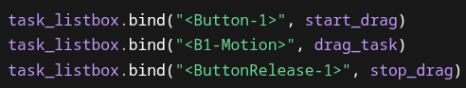

FULL CODE

import tkinter as tk
import json
from tkinter import simpledialog
root = tk.Tk()
root.title("Task List")
root.geometry("500x450")
tasks = []
completed_tasks = 0
drag_start_index = None
def add_task(event=None):
description = task_entry.get()
if description == "":
return
task = {
"description": description,
"completed": False
}
tasks.append(task)
task_listbox.insert(tk.END, description)
save_tasks()
task_entry.delete(0, tk.END)
def delete_task():
selected = task_listbox.curselection()
if selected == ():
return
index = selected[0]
task_listbox.delete(index)
tasks.pop(index)
save_tasks()
def drag_task(event):
global drag_start_index
new_index = task_listbox.nearest(event.y)
if drag_start_index is None:
return
if new_index == drag_start_index:
return
task = tasks.pop(drag_start_index)
tasks.insert(new_index, task)
refresh_listbox()
task_listbox.selection_set(new_index)
drag_start_index = new_index
def load_tasks():
global tasks
global completed_tasks
try:
with open("tasks.json", "r") as file:
data = json.load(file)
tasks = data["tasks"]
completed_tasks = data["completed_tasks"]
for task in tasks:
task_listbox.insert(tk.END, task["description"])
except FileNotFoundError:
tasks = []
completed_tasks = 0
def mark_completed():
global completed_tasks
selected = task_listbox.curselection()
if selected == ():
return
index = selected[0]
task_listbox.delete(index)
tasks.pop(index)
completed_tasks += 1
save_tasks()
update_counter()
def refresh_listbox():
task_listbox.delete(0, tk.END)
for task in tasks:
task_listbox.insert(tk.END, task["description"])
def save_tasks():
data = {
"completed_tasks": completed_tasks,
"tasks": tasks
}
with open("tasks.json", "w") as file:
json.dump(data, file)
def start_drag(event):
global drag_start_index
drag_start_index = task_listbox.nearest(event.y)
def stop_drag(event):
save_tasks()
def update_counter():
counter_label.config(text=f"Tasks Completed: {completed_tasks}")
def update_counter_manual():
global completed_tasks
new_total = simpledialog.askinteger(
"Update Completed Tasks",
"Enter the number you want the running total to be:",
parent=root
)
if new_total is None:
return
completed_tasks = new_total
save_tasks()
update_counter()
task_listbox = tk.Listbox(root, font=("Arial", 14), width=40, height=10)
task_listbox.pack(pady=10)
task_listbox.bind("<Button-1>", start_drag)
task_listbox.bind("<B1-Motion>", drag_task)
task_listbox.bind("<ButtonRelease-1>", stop_drag)
load_tasks()
task_entry = tk.Entry(root, font=("Arial", 14))
task_entry.bind("<Return>", add_task)
task_entry.pack(pady=10)
button_frame = tk.Frame(root)
button_frame.pack(pady=5, fill="x", padx=40)
delete_button = tk.Button(button_frame, text="Delete Task", font=("Arial", 12), command=delete_task)
delete_button.pack(side="left", padx=5)
add_button = tk.Button(button_frame, text="Add Task", font=("Arial", 12), command=add_task)
add_button.pack(side="left", padx=5)
mark_button = tk.Button(button_frame, text="Mark Completed", font=("Arial", 12), command=mark_completed)
mark_button.pack(side="left", padx=10)
counter_frame = tk.Frame(root)
counter_frame.pack(pady=10)
counter_label = tk.Label(counter_frame, text=f"Tasks Completed: {completed_tasks}", font=("Arial", 14))
counter_label.pack(side="left", padx=5)
update_counter_button = tk.Button(counter_frame, text="Update", font=("Arial", 12), command=update_counter_manual)
update_counter_button.pack(side="left", padx=5)
root.mainloop()

